# Ballarat boys united on democracy's birth

* **BY:PIA AKERMAN**
* From:[The Australian](http://www.theaustralian.com.au/)
* February 25, 2013 12:00AM

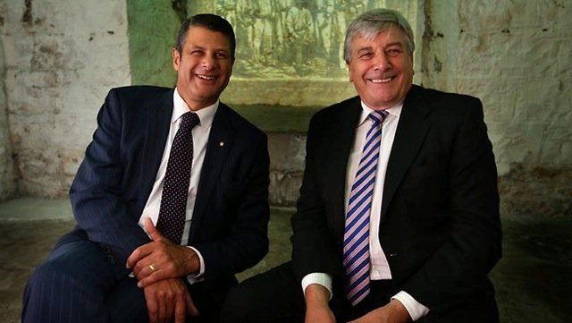

Former political foes Steve Bracks and Rob Knowles are joint patrons of the new Museum of Australian Democracy in Ballarat. Picture: Stuart McEvoy Source:*The Australian*

**THEY used to battle across the floor of the Victorian parliament, but Ballarat boys Steve Bracks and Rob Knowles are firmly united when it comes to the pivotal role their hometown played in kickstarting Australian democracy.**

As Victorian premier, Mr Bracks would often stoush with his NSW counterpart over the historical significance of the miners' revolt compared to the Rum Rebellion.

"I used to have significant differences with my friend and colleague, Bob Carr, who didn't believe that democracy originated in Australia at Eureka," Mr Bracks said yesterday.

"They fought over rum; we fought over a bill of rights, effectively a charter of rights, so I would argue we had a stronger base for that historically."

As joint patrons of the new Museum of Australian Democracy at Eureka, Mr Bracks and Mr Knowles have become experts on the 1854 skirmish in which diggers fought government troops over mining licences.

Mr Bracks said the museum aimed to help Australians understand the struggle for democracy and expand their appreciation for the Eureka Stockade, particularly among younger generations.

"It wasn't by accident; it was by design," he said.

"It was by action; it was by struggle that it was achieved. The appreciation of that helps enormously in nurturing our ongoing democratic traditions."

Mr Bracks and Mr Knowles, a former Kennett government minister, both said they believed Australian democracy remained healthy despite the increasingly vitriolic tone of debate.

"I wouldn't like our democracy to evolve like the American system where people act much more independently so you get horse dealing done on almost every issue," Mr Knowles said.

Mr Bracks, who joined Senator Carr and senator John Faulkner in a review assessing Labor's 2010 electoral performance and future, declined to comment on the party's woes but said Australian democracy would continue to evolve through future governments. "We have robust debates, vigorous debates about the right to have a say, not only at elections but in between elections, and to take action if we need to," he said.

"The great opportunity to participate in the democratic process I think is one that will be enhanced over time."

The museum will officially open in Ballarat in May.